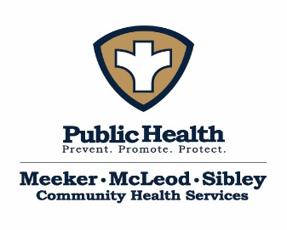
Meeker-McLeod-Sibley Community Health Services Board Workshop Agenda
Date: March 23, 2026 Time: 9:30am-11:30am
Location: McLeod County Government Building – Room: Biscay

Present:
Absent:
Guests:
Purpose of meeting:
Goals for this meeting: | - Develop Workshop Guidelines/Purpose  - Review HMA Proposal  - Establish Budget Plan
Topic | Discussion/Plan |  | Follow up/Responsible Person/Deadline
Workshop Guidelines | MMS CHS does not have workshop guidelines included in any legal framework. Developing these guidelines will help maintain purpose and achieve goals.
Review HMA Proposal @ 10am with Kate and Sarah | Reminder: This is a discussion document that can be tweaked.
Innovation Budget | Total award: $346,324  Yr 1 timeline: March 1, 2025 – June 30, 2026  Yr 1 budget: $179,734  Yr 1 YTD: $140,858.76  Yr 1 Remaining: $38,875.24  Yr 2 timeline: July 1, 2026 – June 30, 2027  Yr 2 budget: $166,590
Other
Parking Lot
Homework/Tasks
Future meeting dates: | Tentative: April 22, 2026 9:30- 11:30
Respectfully submitted by: |  | Recorder for next meeting:

