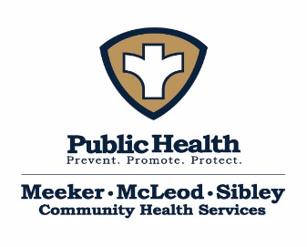
Meeker-McLeod-Sibley Community Health Services Board Workshop Agenda
Date: April 20, 2026 Time: 9:30am-11:30am
Location: Southwest Initiative Foundation – 15 3rd Ave NW, Hutchinson, MN 55350

Present:
Absent:
Guests:
Purpose of meeting:
Goals for this meeting: | - See HMA’s Agenda
Topic | Discussion/Plan |  | Follow up/Responsible Person/Deadline
Welcome
HMA
Other
Parking Lot
Homework/Tasks
Future meeting dates: | May 14, 2026 @ 1pm, Sibley County
Respectfully submitted by: |  | Recorder for next meeting:

